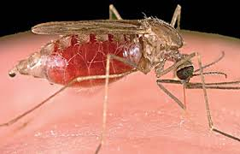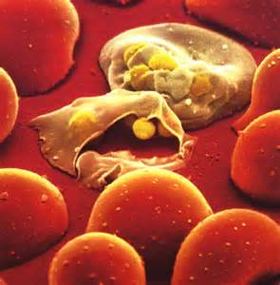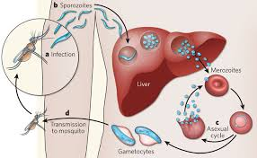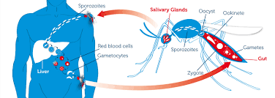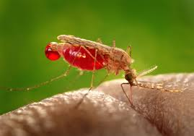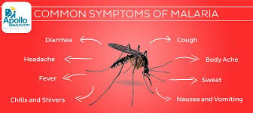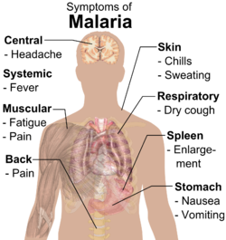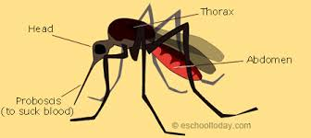

Malaria is a mosquito-borne infectious disease of humans and other animals caused by parasitic protozoans (a group of single-celled microorganisms) belonging to the Plasmodium type.^{[1]} Malaria causes symptoms that typically include fever, fatigue, vomiting, and headaches. In severe cases it can cause yellow skin, seizures, coma, or death.^{[2]} Symptoms usually begin ten to fifteen days after being bitten. If not properly treated, people may have recurrences of the disease months later.^{[1]} In those who have recently survived an infection, reinfection usually causes milder symptoms. This partial resistance disappears over months to years if the person has no continuing exposure to malaria.^{[2]}
The disease is most commonly transmitted by an infected female Anopheles mosquito. The mosquito bite introduces the parasitesfrom the mosquito's saliva into a person's blood.^{[1]} The parasites travel to the liver where they mature and reproduce. Five species ofPlasmodium can infect and be spread by humans.^{[2]} Most deaths are caused by P. falciparum because P. vivax, P. ovale, andP. malariae generally cause a milder form of malaria.^{[1][2]} The species P. knowlesi rarely causes disease in humans.^{[1]} Malaria is typically diagnosed by the microscopic examination of blood using blood films, or with antigen-based rapid diagnostic tests.^{[2]}Methods that use the polymerase chain reaction to detect the parasite's DNA have been developed, but are not widely used in areas where malaria is common due to their cost and complexity.^{[3]}
The risk of disease can be reduced by preventing mosquito bites by using mosquito nets and insect repellents, or with mosquito-control measures such as spraying insecticides and draining standing water.^{[2]} Several medications are available to prevent malariain travellers to areas where the disease is common. Occasional doses of the medication sulfadoxine/pyrimethamine are recommended in infants and after the first trimester of pregnancy in areas with high rates of malaria. Despite a need, no effectivevaccine exists, although efforts to develop one are ongoing.^{[1]} The recommended treatment for malaria is a combination ofantimalarial medications that includes an artemisinin.^{[1][2]} The second medication may be either mefloquine, lumefantrine, or sulfadoxine/pyrimethamine.^{[4]} Quinine along with doxycycline may be used if an artemisinin is not available.^{[4]} It is recommended that in areas where the disease is common, malaria is confirmed if possible before treatment is started due to concerns of increasingdrug resistance. Resistance among the parasites has developed to several antimalarial medications; for example, chloroquine-resistant P. falciparum has spread to most malarial areas, and resistance to artemisinin has become a problem in some parts of Southeast Asia.^{[1]}
The disease is widespread in the tropical and subtropical regions that exist in a broad band around the equator.^{[2]} This includes much of Sub-Saharan Africa, Asia, and Latin America. In 2015, there were 214 million cases of malaria worldwide.^{[5]} This resulted in an estimated 438,000 deaths, 90% of which occurred in Africa.^{[5]} Rates of disease have decreased from 2000 to 2015 by 37%,^{[5]} but increased from 2014 during which there were 198 million cases.^{[6]} Malaria is commonly associated with poverty and has a major negative effect on economic development.^{[7][8]} In Africa, it is estimated to result in losses of US$12 billion a year due to increased healthcare costs, lost ability to work, and negative effects on tourism.^{[9]}

